**Project Planning Design**

***Sprint Delivery Plan***

**Project Name:** Smart Solution for Railways

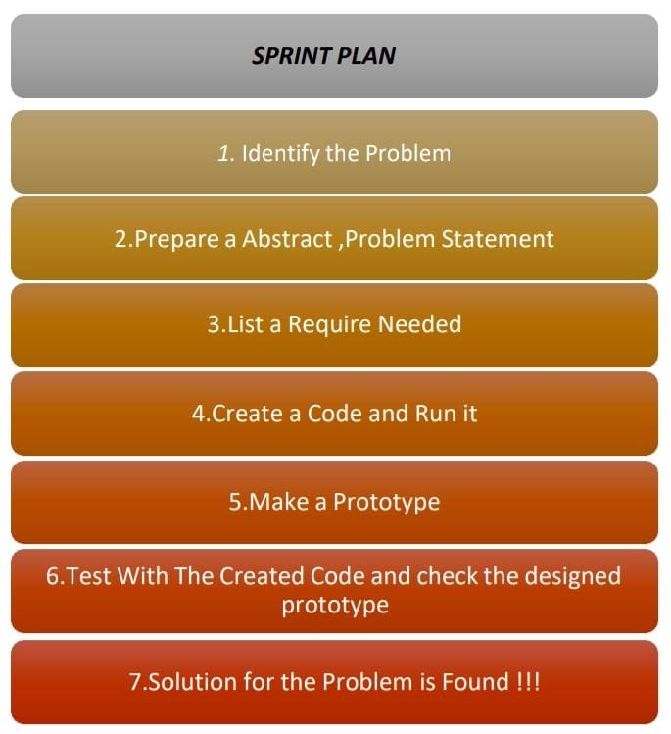**Team ID:** PNT2022MID2